Question: City Lights Simulator
You are provided with an incomplete HTML, CSS, and JavaScript setup for a project called City Lights Simulator.
This project involves creating an interactive cityscape where clicking a button toggles between Night Mode and Day Mode, while window lights in the buildings turn on or off randomly.
Your task is to complete the missing parts of the code so that the simulator functions correctly.

Objectives
- Add the class skyline to the main <div> containing all the buildings in the HTML file.
- Add a gap of 20px to the element with id sky in the CSS file.
- Complete the window light toggle logic in JavaScript so that:
  - The window background color becomes yellow when the light is ON.
  - The window background color becomes gray when the light is OFF.
- Ensure that when the button is clicked:
  - The background color of the sky toggles between sky blue (Day) and black (Night).
  - The button text updates between "Night Mode" and "Day Mode" accordingly.

Constraints
- Do not modify the existing building structures or their IDs.
- Maintain the existing grid layout and building styling.
Code:
index.html
<!DOCTYPE html>
<html lang="en">
<head>
<meta charset="UTF-8">
<meta name="viewport" content="width=device-width, initial-scale=1.0">
<title>City Lights Simulator</title>
<link rel="stylesheet" href="style.css">
</head>
<body>

<div id="sky">
<!-- TODO: Add class skyline to the main div containing the buildings -->
<div id="building">
<div class="window"></div>
<div class="window"></div>
<div class="window"></div>
<div class="window"></div>
</div>

<div id="building2">
<div class="window"></div>
<div class="window"></div>
<div class="window"></div>
<div class="window"></div>
</div>
</div>

<button id="toggle-lights">Night Mode</button>

<script src="script.js"></script>
</body>
</html>

style.css
body {
font-family: Arial, sans-serif;
text-align: center;
background-color: #87CEEB; /* sky blue for day */
transition: background-color 0.5s;
}

#sky {
display: flex;
justify-content: center;
align-items: flex-end;
height: 300px;
/* TODO: Add a gap of 20px between buildings */
}

#building, #building2 {
display: grid;
grid-template-columns: repeat(2, 50px);
grid-template-rows: repeat(2, 50px);
gap: 10px;
background-color: #444;
padding: 10px;
border-radius: 5px;
}

.window {
width: 50px;
height: 50px;
background-color: gray;
border-radius: 3px;
}

button {
margin-top: 20px;
padding: 10px 20px;
border: none;
background-color: #222;
color: white;
cursor: pointer;
border-radius: 5px;
font-size: 16px;
}

button:hover {
background-color: #555;
}

script.js
var building = document.getElementById('building');
var building2 = document.getElementById('building2');
var button = document.getElementById('toggle-lights');
var sky = document.getElementById('sky');

button.addEventListener('click', function() {
var allWindows = [
...building.children,
...building2.children
];

// Randomly toggle each window's light
allWindows.forEach(function(window) {
var lightOn = Math.random() > 0.5;
// TODO: Change the background color of the window to yellow if light is ON, otherwise gray
});

// TODO: Toggle between Night and Day modes
// Change sky background color and update button text
});

Existing Output:
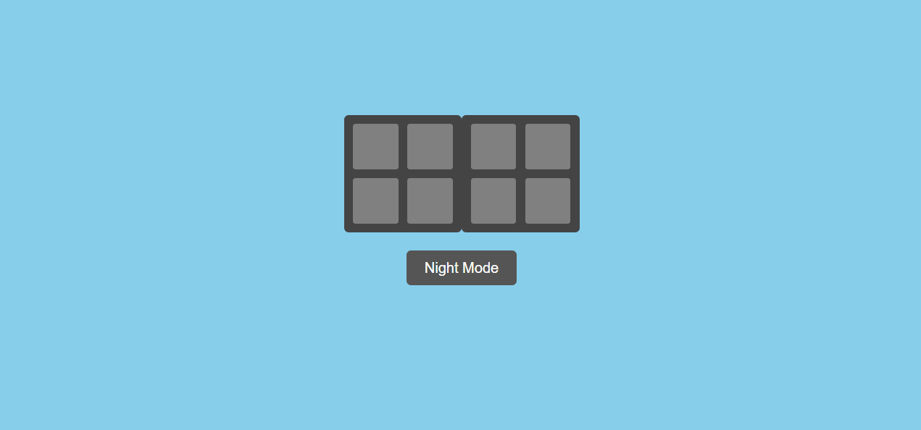
Excepted output:
